­­

**Submitted by: -**

Adarsh Mishra (RK19HZB52)

Ravi Ranjan (RK19HZB53)

Rishabh Katyal (RK19HZB51)

**Submitted to: -**

Mrs. Manu Bali

Online Banking Website

B-tech Computer science and engineering (II semester)

# Table of Content

1. Introduction
2. Project Description
3. Project Content
4. Concepts Used
5. Contribution By Team Members
6. Project Implementation
7. Conclusion
8. References

**INTRODUCTION**

The concept of online banking as we know it today dates back to the early 1980s, when it was first envisioned and experimented with. However, it was only in 1995 (on October 6, to be exact) that Presidential Savings Bank first announced the facility for regular client use. The idea was quickly snapped up by other banks like Wells Fargo, Chase Manhattan and Security First Network Bank.

In the beginning, its inventors had predicted that it would be only a matter of time before online banking completely replaced the conventional kind. Facts now prove that this was an overoptimistic assessment - many customers still harbour an inherent distrust in the process.

Others have opted not to use many of the offered facilities because of bitter experience with online frauds, and inability to use online banking services.

Be that as it may, it is estimated that a total of 55 million families in America will be active users of online banking by the year 2010. Despite the fact that many American banks still do not offer this facility to customers, this may turn out to be an accurate prediction. The number of online banking customers has been increasing at an exponential rate.

Initially, the main attraction is the elimination of tiresome bureaucratic red tape in registering for an account, and the endless paperwork involved in regular banking. The speed with which this process happens online, as well as the other services possible by these means, has translated into a literal boom in the banking industry over the last five years. Nor are there any signs of the boom letting up - in historical terms, online banking has just begun.

**PROJECT DESCRIPTION**

**Project Name:** Online Banking Website

**Developed At:**  Lovely Professional University

**Languages Used:** HTML, CSS, JavaScript

**Software Used:** Visual Studio Code

**Browser Used:** Google Chrome

**Developed By:**  Adarsh Mishra, Ravi Ranjan,

Rishabh Katyal

**Guided By:**  Mrs. Manu Bali

**Description:**

This project is not a pure website which work on internet. This project is just a template of bank website, which can be used with backend to create a perfectly working website. This website is work fine with JavaScript, CSS (Cascading Style Sheet), HTML (Hyper Text Markup Language), with some simple concepts to make it Responsive Web Page.

**PROJECT CONTENT**

This website is consist of various html pages, which are linked to each other with link (either by link or anchor tag).

Following are the HTML file names involved in the project:

1. **home.html** (Home Page)
2. **login.html** (Login Page)
3. **signup.html** (Sign Up Page)
4. **perIntBank.html** (Personal Internet Banking)
5. **corpBank.html** (Corporate Banking)
6. **merBusiness.html** (Merchant Business)
7. **onlTax.html** (Online Tax)
8. **intTransfer.html** ( International Money Transfer
9. **natBanking.html** (National Money Transfer)
10. **billPay.html** (Bill Payment)
11. **fixDep.html** (Fixed Deposit)
12. **eServ.html** (E-Services)
13. **acc.html** (My Account)
14. **aboutUs.html** (About Us)

Following are the CSS files name involved in this project: (Here, we had used a simple convention in the naming of the files: “<html_file_name>CSS.css”

1. **homeCSS.css** (Home Page)
2. **loginCSS.css** (Login Page)
3. **signupCSS.css**(Sign Up Page)
4. **perIntBankCSS.css**(Personal Internet Banking)
5. **corpBankCSS.css** (Corporate Banking)
6. **merBusinessCSS.css**(Merchant Business)
7. **onlTaxCSS.css** (Online Tax)
8. **intTransferCSS.css**( International Money Transfer
9. **natBankingCSS.css**(National Money Transfer)
10. **billPayCSS.css** (Bill Payment)
11. **aboutUsCSS.css** (About Us)
12. **accCSS.css** (My Account)
13. **fixDepCSS.css** (Fixed Deposit)
14. **eServCSS.css** (E-Services)

Following are the JavaScript file names involved in this project:

1. **loginJS.js** (Login Page)
2. **signupJS.js** (Sign Up Page)
3. **perIntBankJS.js** (Personal Internet Banking)
4. **fixDepJS.js** (Fixed Deposit)
5. **billPayJS.js** (Bill Payment)

**CONCEPTS USED**

As above mentioned, this template website is made up of HTML, CSS, and JavaScript.

**Concept used in HTML:**

1. Using link to add external CSS file to it.
2. Using “src” attribute with “script” tag we link external JavaScript.
3. Using “div” tag to separate various part of the webpage to give functionality and style separately.
4. Using “h1” tags to give heading.
5. Using “img” tag to give image in the webpage.
6. Using anchor (“a”) tags to link multiple html files to each other.
7. Using “id” and “class” attributes with different tags to give them style and functionality accordingly.
8. Using “form” tag to use form for login and sign up page.
9. Using “method” attribute’s value as “POST” to give the form data securely.
10. Using “input” tags to make input field for the users. (With it’s different types.)
11. Using “onload”, “onclick”, “onblur”, “onchange” with its value to call the functions which are in the respective JavaScript files on loading of webpage, on clicking of button, on loosing of focus and changing of state respectively.
12. Using “label” tags to create labels for the input fields.
13. Using “select” tags to create drop-down menu or combo-box in the form.
14. Using “option” tags inside “select” tag to give options in the drop-down menu.
15. Using “button” tags to create button of for submitting and resetting of the form.

**Concept used in CSS:**

1. Using “#” and “.” to access elements with their id and class values respectively.
2. Using some pseudo-classes to make somewhat interactive web page. (Without using JS.)
3. Using media queries to make page responsive for some specific display ratios.
4. Using “@import” for importing another CSS file to specific file.

**Concept used in JavaScript:**

(In this project, JavaScript is used mainly for form validation and for interactive buttons.)

1. Using Regular Expression (RegEx) for creating a patter for email and password validations as they have a specific pattern in them.
2. Using “window.location.replace()” to go to specific location on calling it.
3. And using other pre-defined function to create our user-defined functions.

**CONTRIBUTION BY TEAM MEMBERS:**

1. Adarsh Mishra:
   1. Idea of project and structure of it.
   2. Creating all JavaScript files, to make our webpages interactive.
   3. Final touch-up to the project.
2. Ravi Ranjan:
   1. Creating all CSS files, to make our webpages beautiful.
3. Rishabh Katyal:
   1. Creating all HTML files, to add content into it.

**PROJECT IMPLEMENTATION:**

Here are some images of our project.

home.html

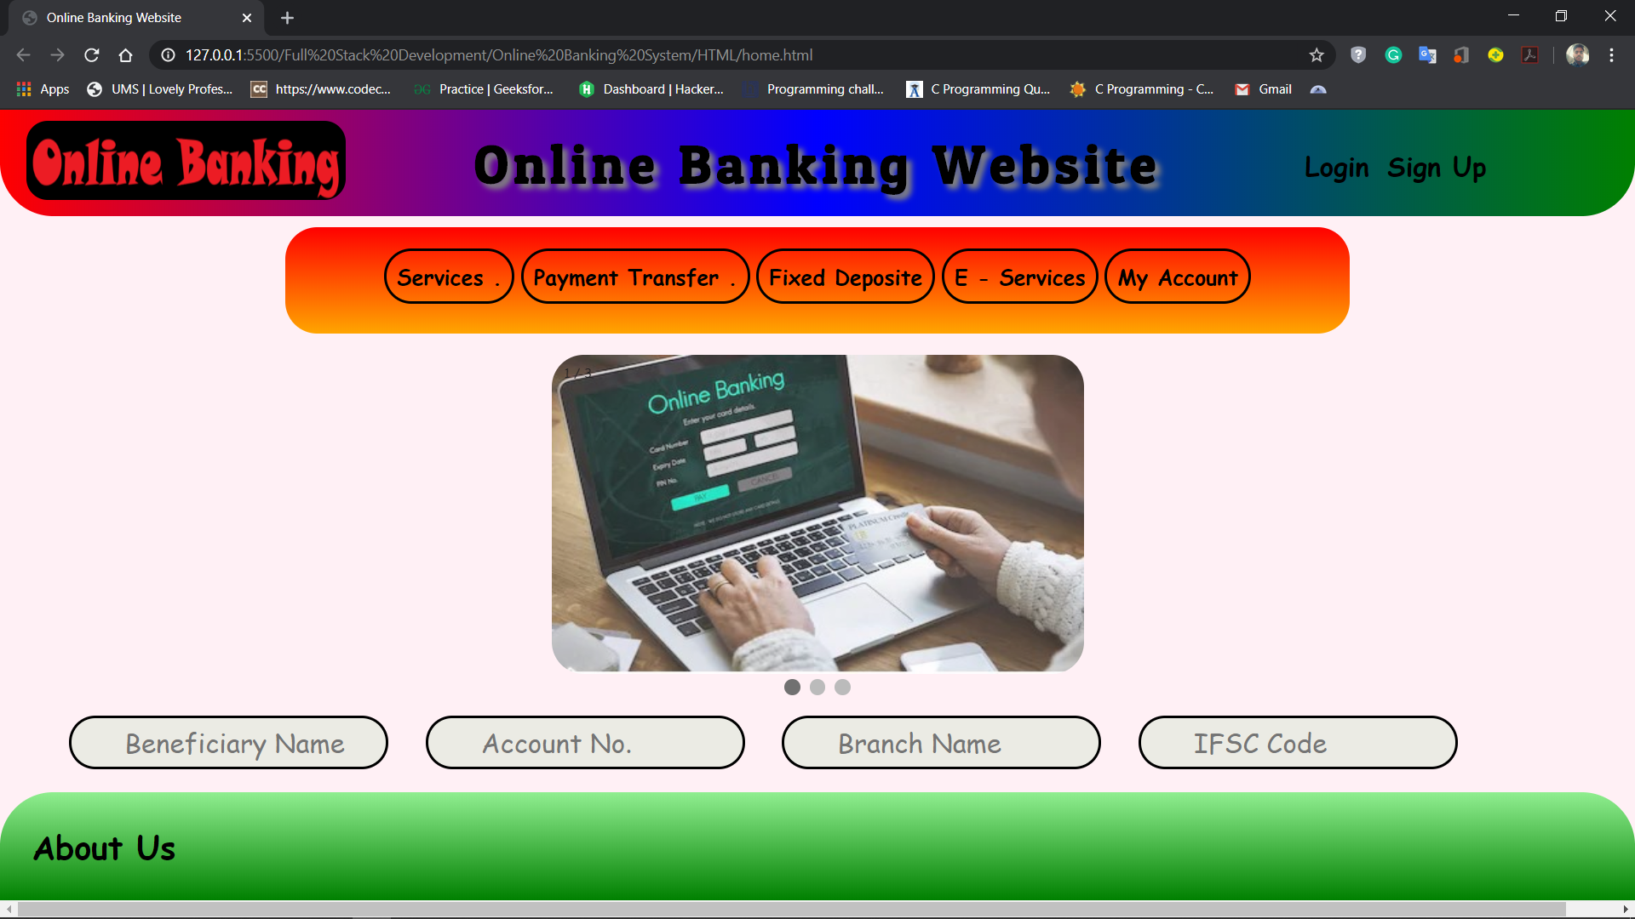

acc.html

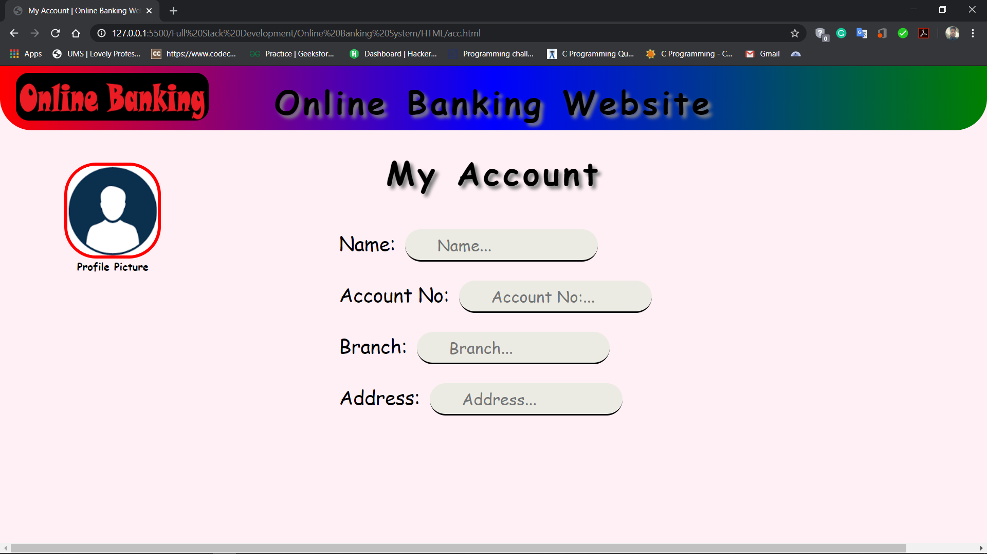

login.html

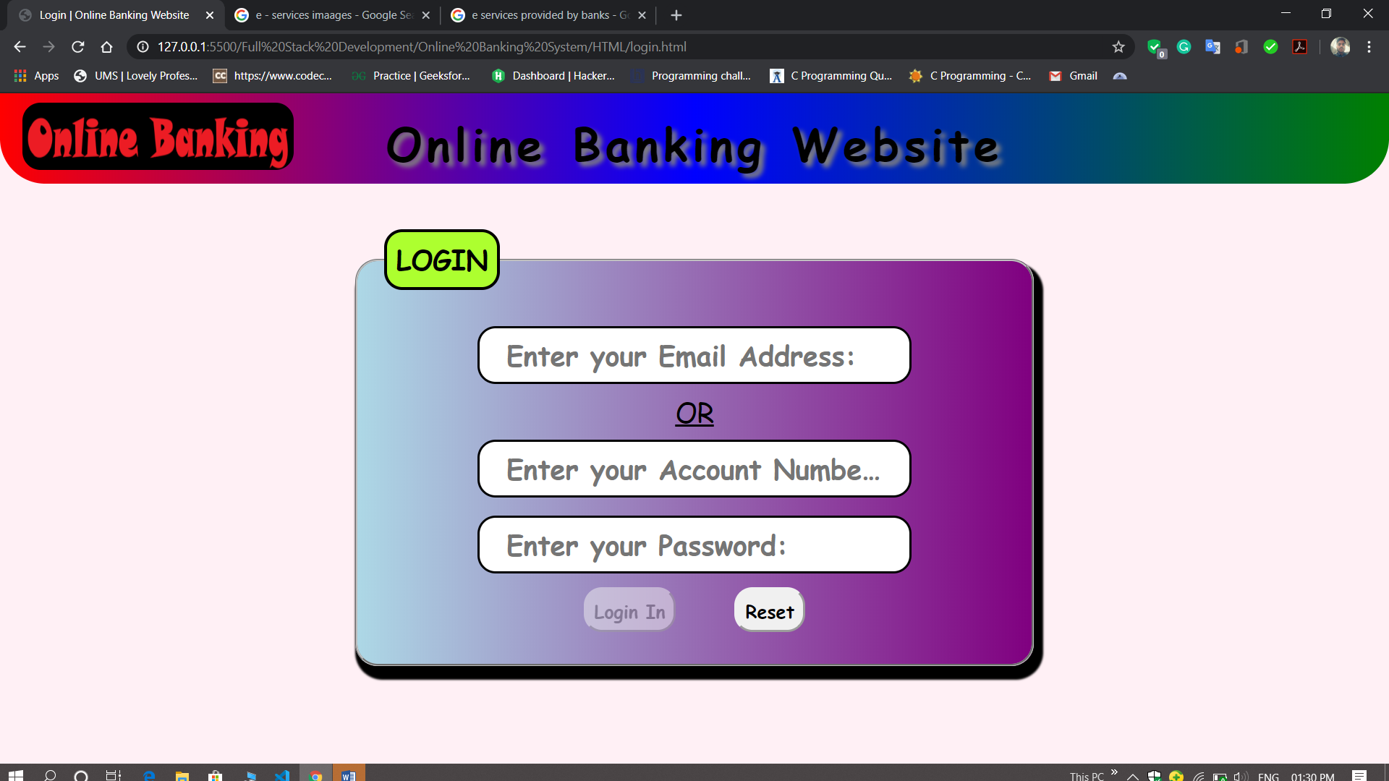

signUp.html

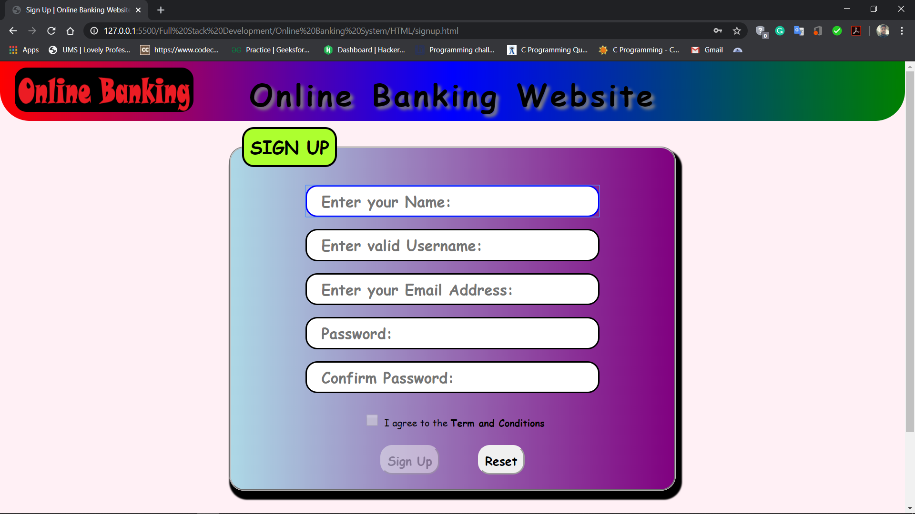

billPay.html

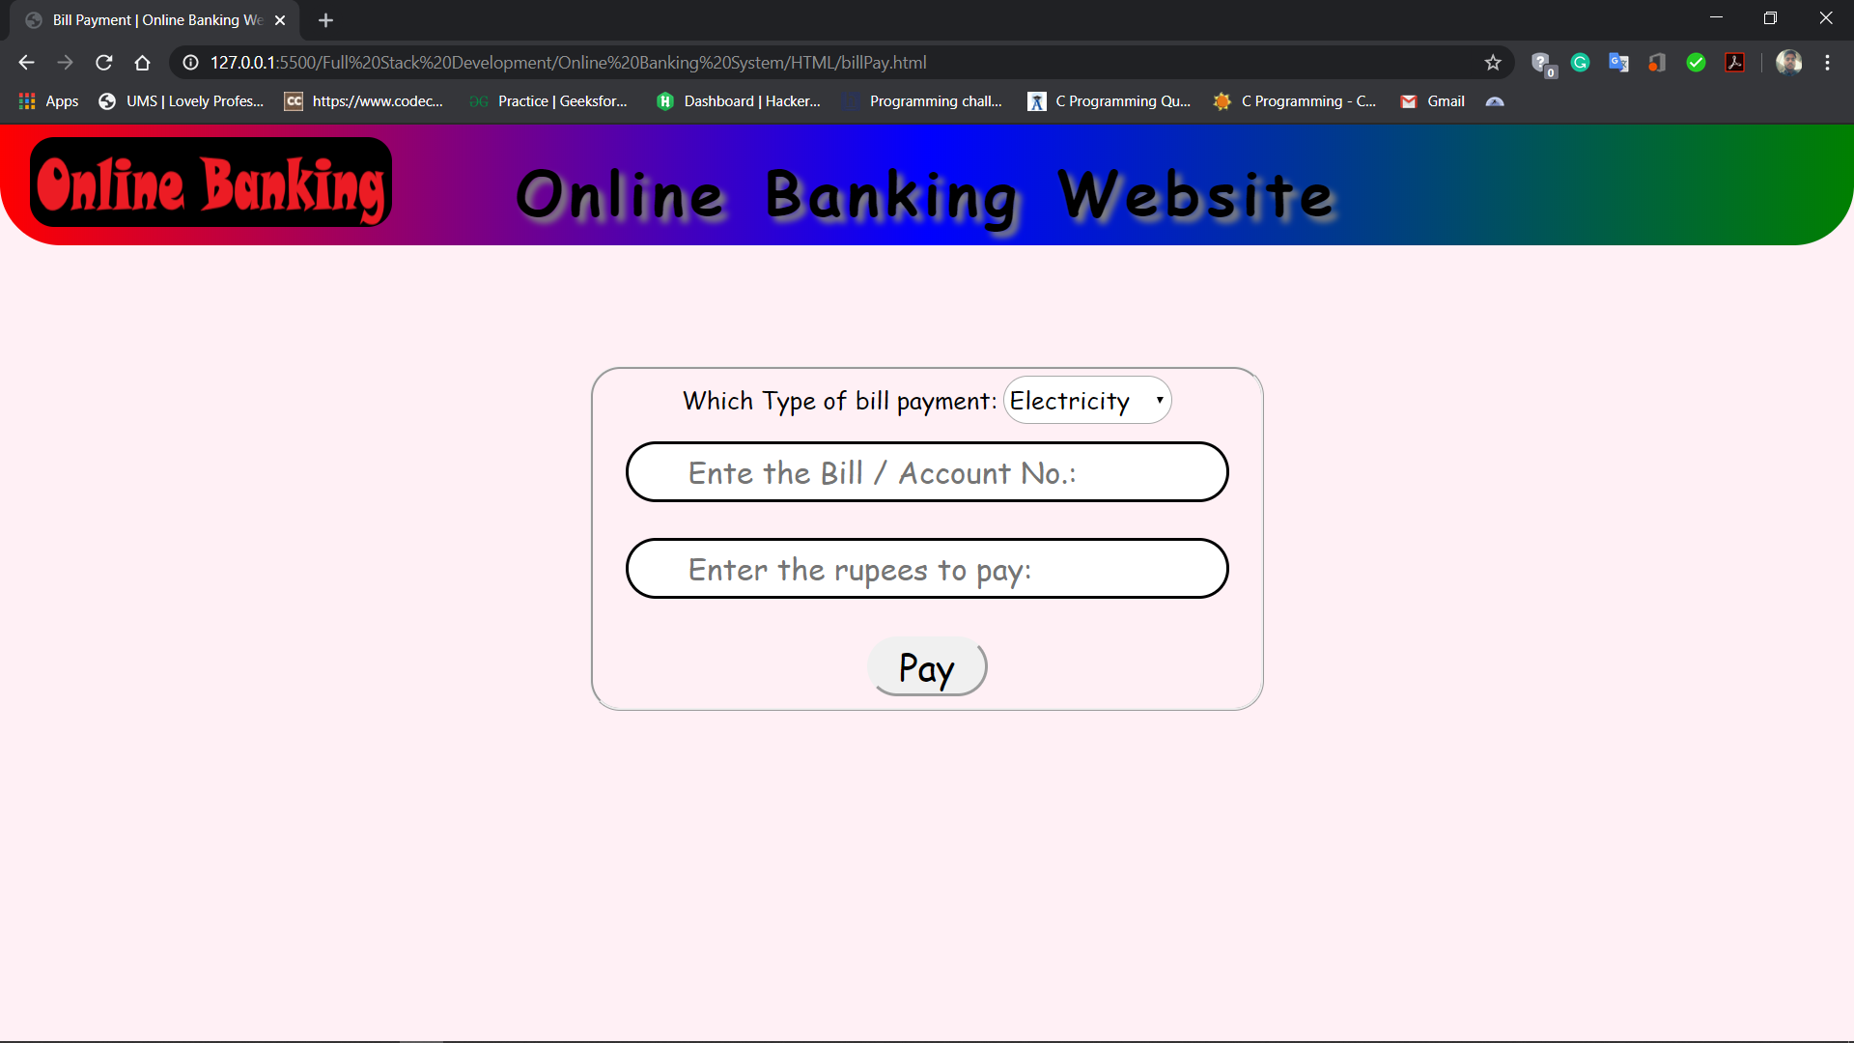

**CONCLUSION**

This project is completed in two scripting languages i.e. HTML and CSS, and one programming language JavaScript.

There are total 14 .html pages which are linked together to create a full website template for online banking.

In this project, Rishabh Katyal made the html files, Ravi Ranjan made the CSS files to make the webpage stylish, and Adarsh Mishra made the JavaScript files to make the webpage interactive to the user and he gave final touchup to the project.

Main idea of the project was given by Adarsh Mishra.

In this project, we all three work equally, with same amount of efforts.

**REFERENCES**

w3school.org

geeksofgeeks.com

developer.mozilla.com